# Flow Sensor (To measure amount of water)

1. How it works:

The Arduino flow meter works on the principle of the Hall Effect. According to which, a voltage difference is induced in a conductor transverse to the electric current and the magnetic field perpendicular to it. Here, the Hall Effect is utilized in the flow meter using a small fan/propeller shaped rotor which is placed in the path of the liquid flowing.

[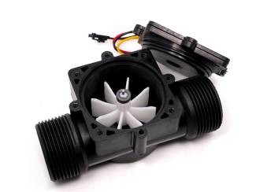](https://301o583r8shhildde3s0vcnh-wpengine.netdna-ssl.com/wp-content/uploads/2014/05/P2231345_011.jpg)

The liquid pushes against the fins of the rotor, causing it to rotate. The shaft of the rotor is connected to a Hall Effect sensor. It is an arrangement of a current flowing coil and a magnet connected to the shaft of the rotor, thus a voltage/pulse is induced as this rotor rotates. In this flow meter, for every liter of liquid passing through it per minute, it outputs about 4.5 pulses. This is due to the changing magnetic field caused by the magnet attached to the rotor shaft as seen in the picture below. We measure the number of pulses using an Arduino and then calculate the flow rate in liters per hour (L/hr) using a simple conversion formula

Pulse frequency (Hz) / 7.5 * 60 = flow rate in L/hr.

**2. Applications and specification:**

* Model: YF-S201
* Sensor Type: Hall effect
* Working Voltage: 5 to 18V DC (min tested working voltage 4.5V)
* Max current draw: 15mA @ 5V
* Output Type: 5V TTL
* Working Flow Rate: 1 to 30 Liters/Minute
* Working Temperature range: -25 to +80℃
* Working Humidity Range: 35%-80% RH
* Accuracy: ±10%
* Maximum water pressure: 2.0 MPa
* Output duty cycle: 50% +-10%
* Output rise time: 0.04us
* Output fall time: 0.18us
* Flow rate pulse characteristics: Frequency (Hz) = 7.5 * Flow rate (L/min)
* Pulses per Liter: 450
* Durability: minimum 300,000 cycles
* Cable length: 15cm
* 1/2" nominal pipe connections, 0.78" outer diameter, 1/2" of thread
* Size: 2.5" x 1.4" x 1.4"

**This sensor is used wherever there is a need to measure the flow of liquid. It is used in Smart irrigation and also to make a flow meter for taps and showers.**

**3. Limitations: On the Arduino Uno or Nano, they can only be connected to D2 or D3 due to a hardware feature built into the Micro Controller**

# 4. Connections

1. Sensor pins: There are 3 pins on this sensor, and they are as follows:
   1. Red wire : +5V
   2. Black wire : GND
   3. Yellow wire : PWM output.

b) The following pins are connected to the arduino:

|  |  |
| --- | --- |
| Arduino pins | Sensor Pin |
| 5V | Red wire |
| GND | Black wire |
| Digital Pin 2 | Yellow wire |

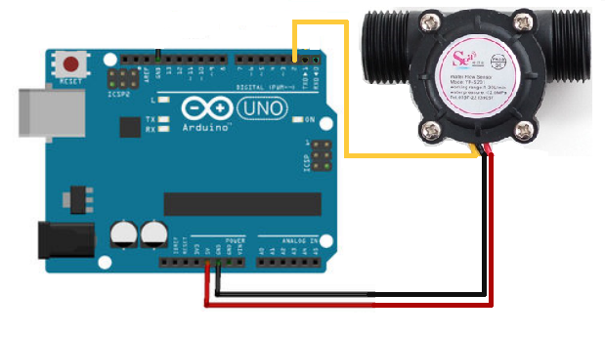

5. Library required for working of distance sensor: NIL

**6. Errors and Troubleshooting**

**If you are getting only 0 values,**

* 1. **Check wiring, maybe power pin is exchanged with gnd, maybe data pin is mapped to different pin in the code and different in your wiring**
  2. **Check direction of arrow on the sensor and blow in the correct direction**
  3. **Check baud rate if the serial monitor indicates weird readings.**